
Department of Mechanical Engineering

EMCH 368
MECHATRONICS

Lab 03
Sound

Last Edited: 01/23/2024 by A.Vereen
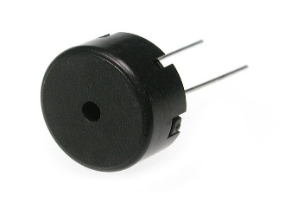
A piezo is a small element that vibrates when it receives electricity. When it moves, it displaces the air around it, creating sound waves. If your piezo has a + marked on one end, this is the one that is supposed to connected to power. If not, this is not a polarized component.

Exercise 1: Creating a Light Theremin

A theremin is a musical instrument that makes sound based on the movements of a musician’s hands around the instrument by reading capacitive changes on the sensor antennae. In this lab, you will develop a light-sensitive theremin that uses a phototransistor to detect the amount of light. You might have noticed that in the previous lab, the ADC reading on the serial monitor did not range all the way from 0 to 1023. The fixed resistor connecting to ground limits the low end of the range, and the brightness of your LED limited the high end of the range. For the theremin, you will learn to calibrate a sensor to take advantage of as much of the ADC’s range as possible.

Your goal is to create a circuit that meets the following criteria:
- Create a theremin that uses a phototransistor to detect light
- The sound will be output by a piezo and will be controlled by the light intensity detected by the phototransistor
- Calibrate the piezo based on the voltage range of the phototransistor

Materials:
- 1 set of long red and black jumper wires
- 1 piezo
- 1 phototransistor
- 1 10k-ohm resistor

Building the Circuit:
- Connect a red wire to the 5V pin on the Arduino and put the other end in one of the long (+) bus lines in the breadboard.
- Connect a black wire to the ground pin on the Arduino to the adjacent long (-) bus line on the breadboard.
- Connect one end of the piezo to ground, and the other to digital pin 8 on the Arduino.
- Place the phototransistor on the breadboard, connecting the anode (long end) to 5V.
- Connect the cathode (short end) to the Arduino’s Analog In pin A0. Also connect this end to ground with a 10 kilohm resistor.
- Connect USB power to the Arduino.

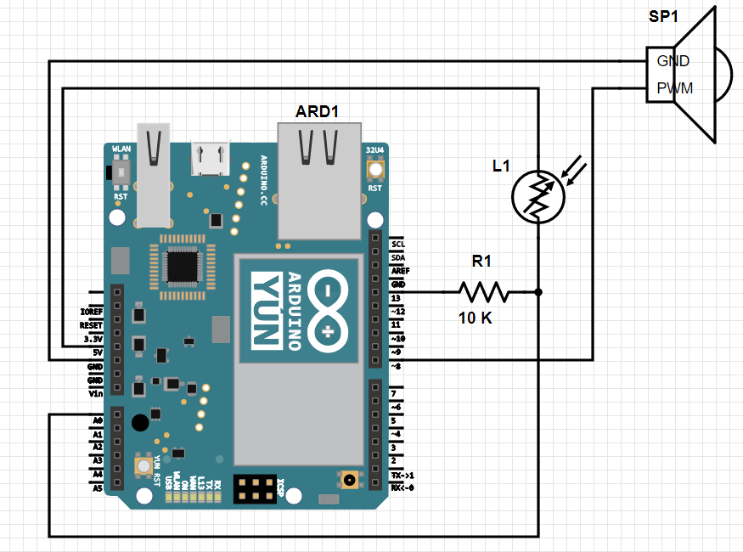

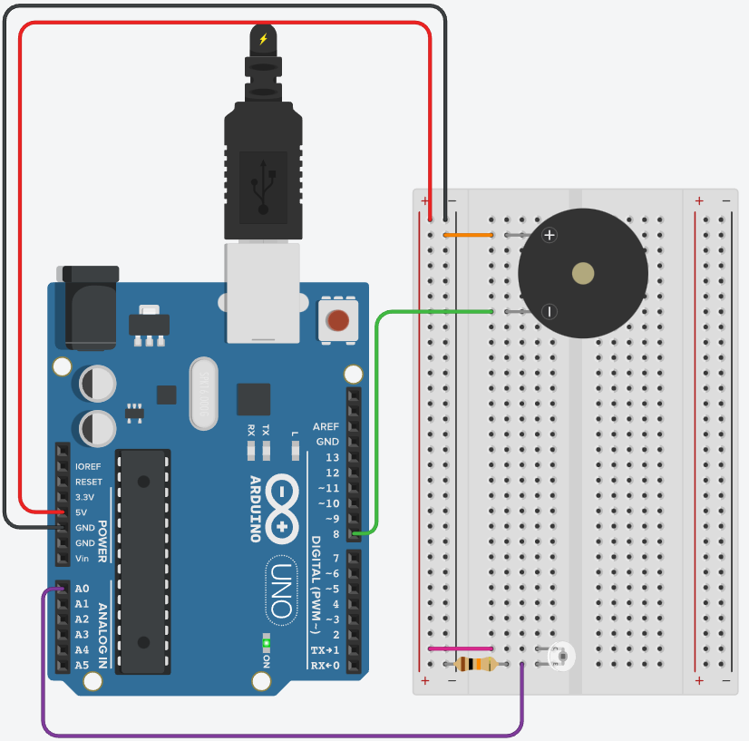
Exercise 1 Circuit
Writing the Program:

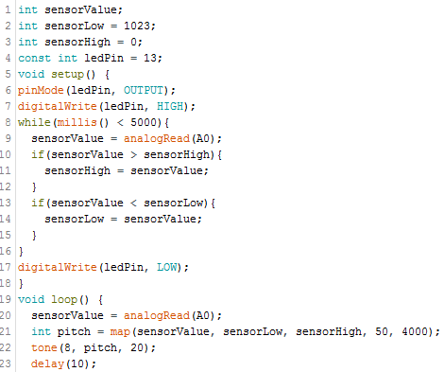

Create the variable sensorValue to hold the reading from the phototransistor. Next, create variables for the low and high values. Initialize the low value to be 1023 and the high value to be 0. When you first run the program, you’ll compare these numbers to the sensor’s readings and update them to the true values.



Create a constant named ledPin. Use this pin as an indicator for when the sensor is calibrating. Pin 13 is an on-board yellow LED of the Arduino.



The calibration will be performed during the void setup(). Set the LED pin as an output, and turn it on. It will remain on while the sensor calibrates.

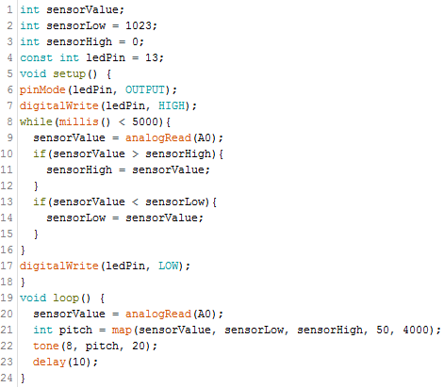

This while loop is where we will calibrate the sensor. A while loop is similar to a for loop, but has a few major distinctions. for() loops have an initialization, a condition, and an update, whereas while() loops essentially just have a condition. while() loops will run indefinitely until the specified condition is no longer true. In this case, we want the while loop to run for 5 seconds
In the loop, the ADC reading from the phototransistor will be compared to the high/low values you initialized earlier. When you run the code, you will have 5 seconds to calibrate your sensor by moving your hand over the phototransistor. The true high and low values of the phototransistor will then be updated as sensorHigh and sensorLow.

After the 5 seconds of calibrating, the actual program begins. The variable pitch will be the frequency of the note that the piezo will play. The value of the pitch will be determined by mapping the ADC reading from the phototransistor to a frequency range of 50 to 4000 Hz.
The tone() function plays the sound. It needs the pin on which to play the sound (pin 8), the pitch, and the duration (try 20 milliseconds to start).

Using the Circuit:
When you begin the program on the Arduino, you will have 5 seconds to calibrate the system. Move your hand up and down above the phototransistor. The closer you replicate the motions you expect to use while playing the instrument, the better the calibration will be. After 5 seconds, the calibration will be complete, and the LED on the Arduino will turn. The piezo will then begin making noise! As you change the amount of light that hits the phototransistor, the pitch of the piezo should change.

Exercise 2: Keyboard Instrument
Now that you have an idea of how sound is created electronically, let’s apply it to a more familiar application: a keyboard instrument. By assigning buttons to play a specific frequency on the piezo, you will create a 4-button musical instrument. While it’s possible to simply hook up each switch to different digital inputs, in this project, you’ll be constructing something called a resistor ladder. This is a way of reading a number of switches using an analog input instead. You will hook up 4 pushbuttons in parallel, each connected to power with its own resistor. When you press each button, a different voltage level will pass to the input pin.

Your goal is to create a circuit with the following criteria:
- Create a musical keyboard using 4 pushbuttons that each play a unique frequency
- Connect the pushbuttons in a resistor ladder that connects to a single analog input pin
- Use a piezo to play sounds according to the states of the pushbuttons

Materials:
- 1 set of long red and black jumper wires
- 1 piezo
- 4 switches
- 1 220-ohm resistor
- 2 10k-ohm resistors
- 1-megohm resistor
Building the Circuit:
- Remove USB power before tampering with the circuit
- Clear all the components from the breadboard except the lines to the power and ground buses.
- Connect one end of the piezo to ground and the other end to digital pin 8
- Place the switches as shown below. Connect the first one directly to power. Connect the second, third, and fourth switches to power through a 220-ohm, 10-kilohm, and 1-megohm resistor, respectively.
- Connect all the switches’ outputs together in one junction. Connect this junction to ground with a 10-kilohm resistor. Also connect to it to analog pin A0. Each of these resistors acts as a voltage divider.
- Plug in USB power and upload your code.
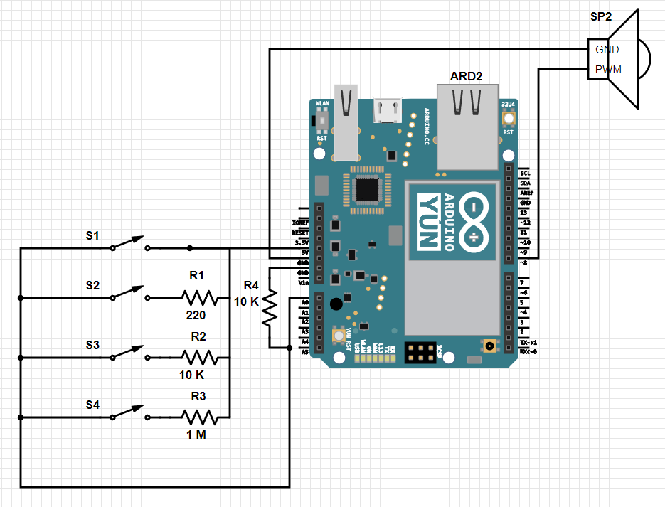
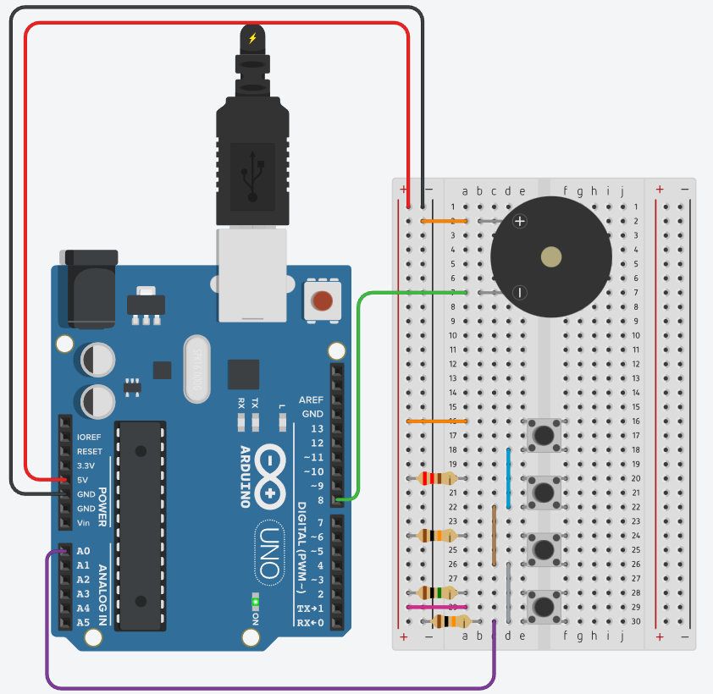
Exercise 2 Circuit
Writing the Code:

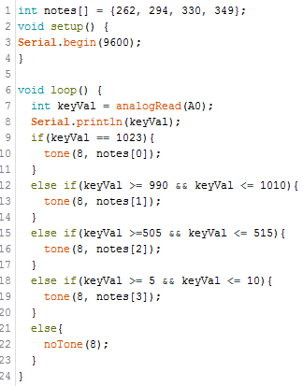

Set up an array of four notes using the frequencies listed above. Notice how an array is created by using square brackets at the end of the array name. The items in the array are listed inside curvy brackets.



Start the serial communication with the computer.



Begin the program by having the Arduino get an ADC reading from pin A0, and print it in the serial monitor.


Set up a series that if statements that will tell the piezo what frequency to play. If the value of A0 matches one of your if statements, you can tell the Arduino to play a tone. For example, if the first button is pressed, the reading should be 1023 (because there is no resistor) and the first note in the array should be played. notes[0] means that the 0th number in the array will be returned. Keep in mind that computers start counting at 0, so really it will return the first number in the array, 262.
Using the Circuit
Whenever you press each button, a different note will play within the same musical key. If you don’t hear any sound, check the serial monitor. It should display the ADC reading. If you are seeing a number that is far outside any of the ranges you specified in the code, you may have used the wrong resistor.
It’s possible your circuit is a little “noisy” and the ADC values fluctuate some while the button is being pressed. To accommodate for this variation, you may need to adjust the bounds of your if statements.

Comprehension Tasks
These are in lab tasks to test how well you’ve understood the exercises. These tasks may consist of but are not limited to requesting alterations to any hardware and software in any of the exercises to achieve a specified functionality. Additionally, TA’s may request you to verbally communicate the meaning and purpose of any component or code. You are encouraged to read through the documentation at https://www.arduino.cc/reference/en/ for a more developed understanding of the functions and hardware you are using. Details from the Arduino reference will be the subject of some questions for this part of your grade.

Challenge Exercise
This is an unguided activity to test mastery of the skills developed in this and previous labs. Using map() and analogRead() produce a 4-frequency buzzer using only a potentiometer as an input. There should be five states the device should operate in, off and four additional tones. The frequencies [329, 415, 494, 622] should be used for the tones. Each state should be reachable by interacting with the potentiometer alone. You will have to explain and justify the code and hardware. You are encouraged to look back upon all your prior work for inspiration.

Lab 3 Code Appendix (in order of appearance):
while(condition) - The while loop is used to repeat a block of code enclosed in curly brackets. The loop will continue as long as the condition inside the while loop’s parenthesis are true.

millis() – reports how long the Arduino has been running (in milliseconds) since it was last powered on or reset.

map(value, fromLow, fromHigh, toLow, toHigh) - this functions scales values for you between two different ranges of numbers. For example, the Arduino’s ADC outputs 0-1023 for a range of 0-5 volts. If you wanted to know how many volts an ADC value of 150 corresponds to, you could use map() in the following way: map(150, 0, 1023, 0, 5)

tone(digital output pin #, frequency, duration) – generates a square wave of the specified frequency. A duration can be specified, otherwise the wave continues until noTone() is called. The output pin can be connected to a piezo buzzer or a speaker to play tones.

Arrays – Arrays are a handy tool for keeping a list of values under one variable name. To declare an array, start as you would with a regular variable, but follow the name with square brackets: [ ]. After the equals sign, list your values in curly brackets.

noTone() – stops the generation of a square wave triggered by tone().

Lab 3 Grading Rubric:
- Exercise 2 Circuit fully built. (10 points)
- Exercise #1 works (15 points)
- Exercise #2 works (15 points)
- Comprehension Tasks (5 points)
- Challenge Exercise (5 points)

Grade distribution template (total 50 points)
- 10 points for built, but not working exercise 2 circuit.
- Exercise grade = (30 points/# of exercises) * (0, 0.5, 1) = zero, half or full exercise grade.
- 5 points for a competent and complete response to any comprehension tasks.
- 5 points for a working circuit that meets all stated requirements.

